A574-US-ME-Saco River Oxbow near Fryeburg-Fluted Point-Ramah Chert-c 13,000 BP

 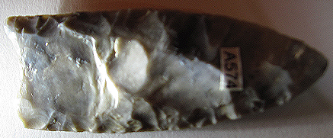

US-ME-Saco River Oxbow near Fryeburg-Fluted Point-Ramah Chert-c 13,000 BP

**Case no.: 11**

**Accession Number: A574**

**Formal Label:** US-ME-Saco River Oxbow near Fryeburg-Fluted Point-Ramah Chert-c 13,000 BP

**Display Description:**

This extremely rare Ramah Chert originated from northern Labrador, but the finished fluted point was found along the Saco River at an ancient Oxbow near Fryeburg, Maine. It is unknown whether the Ramah chert was transported in a raw state and finished in Maine or whether it was transported as a fluted point. In either case it was transported along a North Atlantic route by dugout canoes through the Belle Isle Strait down the Newfoundland, Nova Scotia and Maine Coasts. Then it was transported up the Saco River. The maritime fishers penetrated the interior of the Maritime waterways in dugouts when the freshwater levels were higher than today.

The point was found in the spring, March 7, 1967, when the soil was freezing and thawing and this projectile point was found from a canoe as it was leaching out of the muddy banks at low water. No other artifacts were noted at the time.

**LC Classification:**

**Date or Time Horizon:** 13,000 BP

**Geographical Area:** Saco River Oxbow near Fryeburg

**Map:**

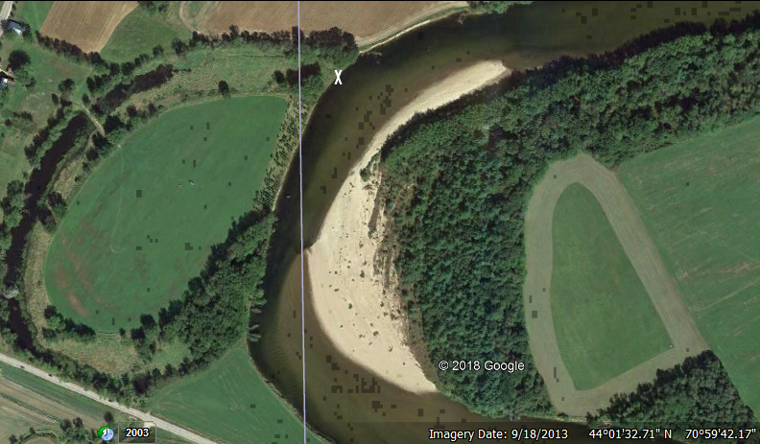

**Location of the fluted point**, March 7, 1967, **on the Saco River near Fryeburg, Maine.**

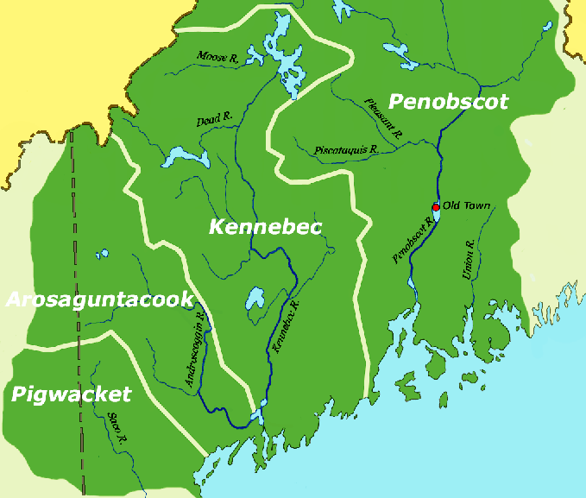

This map shows the Algonquian Eastern Abenaki peoples’ distribution in the Protohistoric Period and the location of the Pigwacket area enclosing the Saco River. After https://upload.wikimedia.org/wikipedia/commons/1/11/Wohngebiet_Oestlicheabenaki.png

Four major rivers (Penobscot, Kennebec, Androscoggin and Saco) offered transportation by Paleo Period dugout canoes into the interior of Maine during the Pleistocene when dugouts could only ply the major rivers, since the water levels were down. Later Abenaki names of these rivers offer important insights as to how the rivers were regarded by later canoeists as the water levels began to increase.

“Penobscot” was a mispronunciation of the Abenaki Penawapskewi or "descending ledges" which indicated the type of portages used in canoeing the river between Pannawambskek, "where the ledges spread out, (i.e., at Old Town) and Bangor (another Abenaki village of unknown name).

“Kennebeck” was an Anglicization of Kínipekʷ/, meaning "large body of still water. "

“Androscoggin” was an invention by Gov. Edmund Andros (1637–ca. 1714) from Arosaguntacook ("Refuge of Rocks River).

 "Saco" comes from the Eastern Abenaki word “Sɑkohki”, meaning "land where the river comes out".

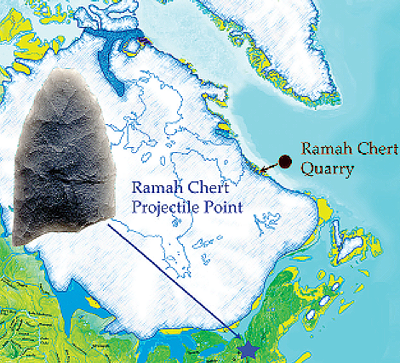

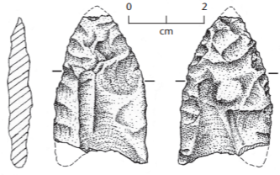 

**Ramah chert quarries were restricted to refugia on the northern Labrador coast at the extent of the Laurentide Glacier at 13,000 BP when fluted points were being made in Northeast North America. If the Solutrean hypothesis of Dennis Stanford is valid then possibly the trajectory of the Maritime Archaic peoples could have come from Greenland to the Ramah chert quarries’ refugia in northern Labrador. As these people proceeded south from the Ramah chert quarries they explored the rivers penetrating the mainland. The finds of Ramah chert along the rivers of Maine and along the margins of the Champlain Sea parallel the** distribution of classic Paleoindian sites (ca. 11,000-10,000 BP) and marine fossils from that included white, common finback, humpback and bowhead whales, harbor porpoise, ringed, and hooded seals**, suggesting** that these marine resources were exploited along two trajectories. One down the St Lwrence River into the Champlain Sea and the other up the major riverws from the Atlantic Ocean (Loring 1981). Bruce Borque (2001) suggests that the Early Paleo Period fluted point assemblages include more exotic cherts (including Ramah chert) than do the non-fluted point assemblages of the Late Paleo Period. This would be explained by the3 fact that these exotic cherts come from the refugia in Northern Labrador as the interior land mass was covered with ice. As the Laurentide glaciation retreated and the region became more forested Archaic people became more sedentary, earlier exploration of Maritime rivers diminished.

**A new paradigm appears to be supported by this new data. Since the direction of diffusion of the exotic cherts was from the refugia on the northern Labrador from the north to the south down through the Belle Isle Strait down the Maritimes’ coast, this suggests that the Paleo “Fluted Point Peoples” had their origins in the north. When the Stemmed Point Peoples investigated these rivers much later they found that there were already others living there. The amalgamation of these two groups may have produced the Abenaki Algonquians.**

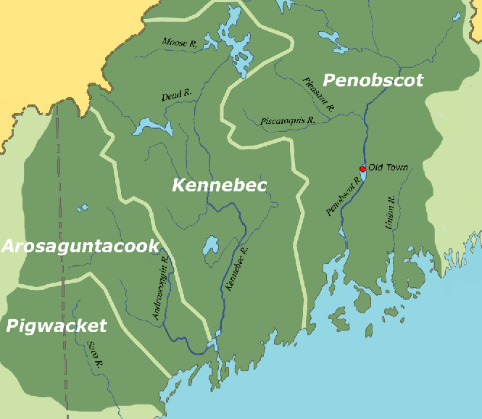

**GPS coordinates:** 44° 01′ 34.16″ N, 70° 59′ 50.73″ W, at the confluence of an old stream bed.

**Cultural Affiliation:** Fluted Point People

**Media:** Ramah Chert

**Dimensions:** L 82.08 mm, 3.23 in; W 34.04 mm, 1.34 in

**Weight: 35 gm, 1.125 oz**

**Condition: original**

**Provenance:** R. Coffman, March 7, 1967, 44° 01′ 34.16″ N, 70° 59′ 50.73″ W, at the confluence of an Oxbowand the Saco River**.**

**Discussion:**

The descendants of the users of this Ramah chert fluted point may be the Abenaki who established a major village known as Pequawket, or "crooked place" a reference to the large bend in the Saco River. It was inhabited by the Sokokis tribe, whose territory along the stream extended from what is now Saco on the coast, to Conway, New Hampshire.

**References:**

# Bourque, Bruce. 2001. Twelve Thousand Years: American Indians in Maine. University of Nebraska Press.